Patient Health Monitoring Data Pipeline using AWS

BUSINESS SCENARIO
A hospital receives patient health monitoring files every hour from:
- ICU monitoring systems
- Wearable health devices
- Hospital management systems
- Emergency care systems

The hospital wants to:
- Store incoming patient data securely
- Validate health records automatically
- Detect corrupted files
- Clean and transform patient data
- Catalog metadata automatically
- Store processed healthcare data
- Separate bad patient records
- Maintain production-ready ETL workflows

Objective
Build a healthcare ETL pipeline that processes patient monitoring data securely.

PROJECT GOALS
build a system that:
- Ingests patient data
- Validates incoming files
- Cleans medical records
- Detects invalid patient readings
- Stores transformed healthcare data
- Handles schema changes

HEALTH METRICS TO TRACK
| Metric | Example |
| ---------------- | ------- |
| Heart Rate | 72 BPM |
| Blood Pressure | 120/80 |

| Oxygen Level | 98% |
| Temperature | 98.6 F |
| Respiration Rate | 16/min |

S3 storage – patient s-health-monitor-bucket

raw/
Vitals/
Patient/
Device/
Processed/
Vitals/
Patients/
Reports /
Rejected/

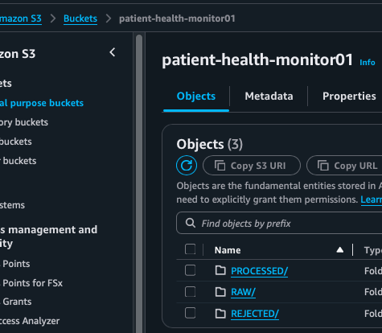

CREATION OF IAM IMPLEMENTATION

Glue IAM Role
Lambda IAM Role

SAMPLE HEALTHCARE DATA

FILE 1 — patient_vitals.csv

patient_id,timestamp,heart_rate,blood_pressure,oxygen_level,temperature
P1001,2025-01-10 08:00:00,72,120/80,98,98.6
P1002,2025-01-10 08:05:00,95,140/90,96,99.1
P1003,2025-01-10 08:10:00,45,90/60,88,101.2
P1004,2025-01-10 08:15:00,,130/85,97,98.4
P1005,2025-01-10 08:20:00,110,150/95,,100.1
P1005,2025-01-10 08:20:00,110,150/95,,100.1

FILE 2 — patient_details.csv

patient_id,name,age,gender,city,disease
P1001,Rahul Sharma,45,Male,Delhi,Diabetes
P1002,Priya Verma,52,Female,Mumbai,Hypertension
P1003,Amit Singh,60,Male,Pune,Heart Disease
P1004,Neha Kapoor,29,Female,Delhi,Asthma
P1005,Rohit Jain,48,Male,Jaipur,Diabetes

FILE 3 — device_logs.csv

device_id,patient_id,device_type,status,last_sync
D101,P1001,SmartWatch,Active,2025-01-10 08:00:00
D102,P1002,Oximeter,Inactive,2025-01-10 07:50:00
D103,P1003,HeartMonitor,Active,2025-01-10 08:05:00

DETECT FOLLOWING:

| Issue | Example |
| ------------------------ | ------------------ |
| Null values | heart_rate missing |
| Duplicate records | P1005 repeated |
| Critical health readings | oxygen_level = 88 |
| Missing patient metrics | oxygen_level blank |
| Schema changes | new column added |

AWS CRAWLER TO READ HEALTH CARE BUCKET RAW DATA
Automatically discover healthcare schema.

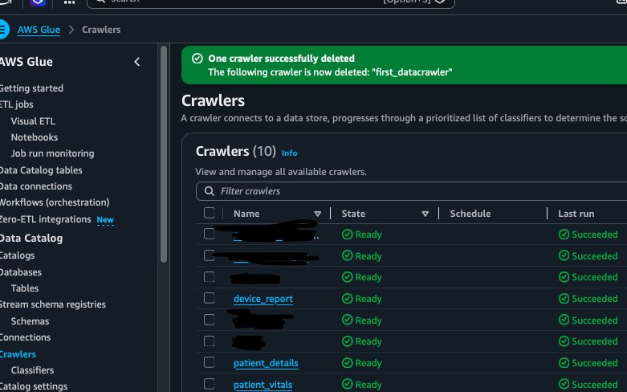

DATABASE AND TABLE AUTOMATICALLY SCANNED FROM RAW BUCKET

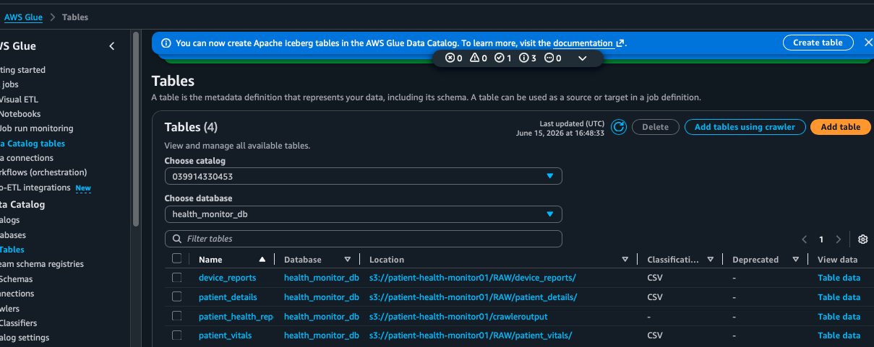

MAIN HEALTHCARE ETL PIPELINE USING PYSPARK

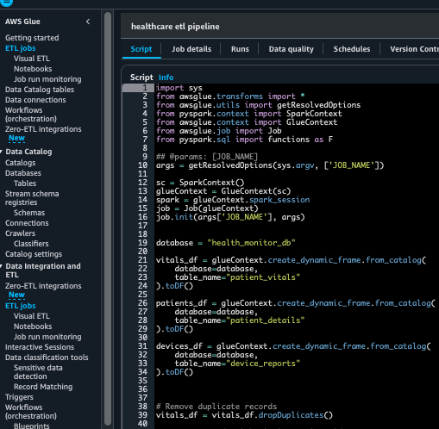
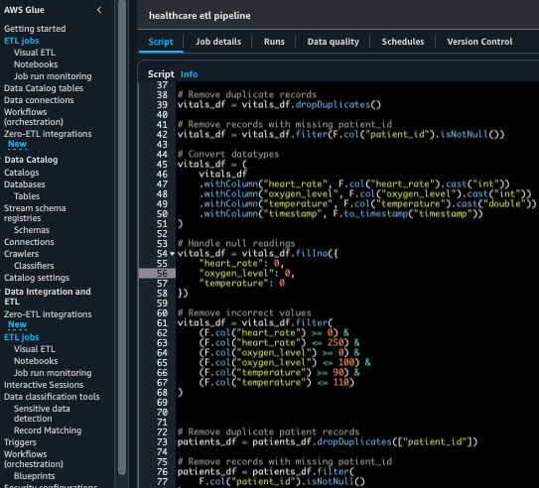
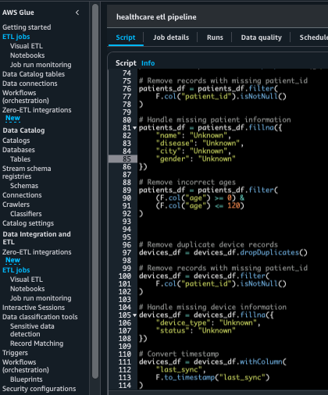
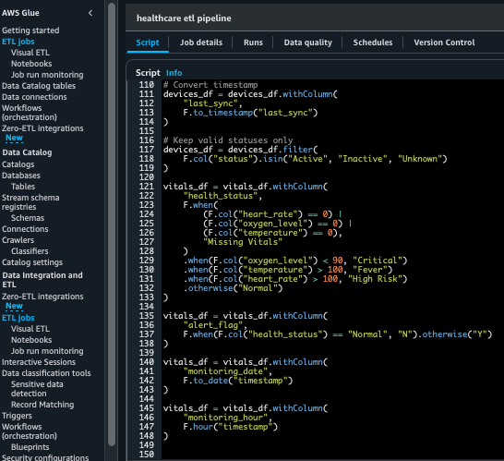
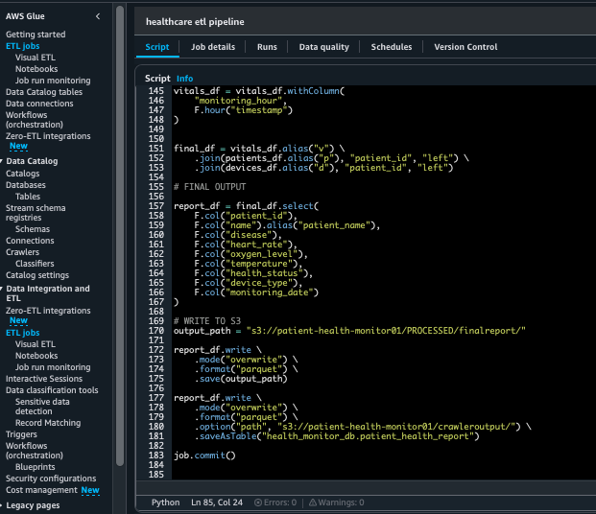

PROCESSED DATA IN PARQUET FORMAT

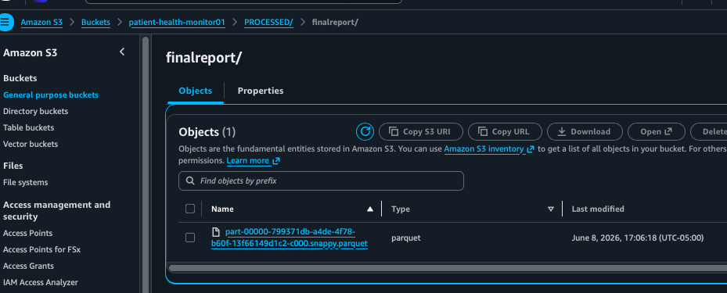

OUTPUT
